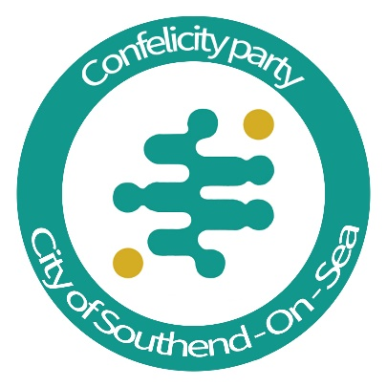

Minutes
June 12th, 2023, 7pm to 9pm
The Castle Hotel

Financial reports

Connor emailed the Electoral Commission to ensure no issues with Brian Ayling’s account. Awaiting response.

Connor has not heard from Coop bank.

James will look at Santander.

Submitted statement of accounts for the year in April. The party spent below £1500 for the year.

Submitted quarterly reports.

Electoral Commission has marked quarter one as not required.

We are required to pay £25 for the party to stay registered. The deadline is August.

Expenses forms for candidates need to be filled out. Deadline pending. Jon overseeing.

We are able to meet our current financial commitments.

Funding

Lee Clark has accepted the position of Head of Fundraising

Arrange one September

Strategy

Find causes to get behind.

- Jon is working against sewage
- Beach cleans
- Education of the political system (Connor)
- Association with Ward associations

Leigh and Echo ads.

Tris has put himself forward for candidacy.

Shadow positions discussed

Constitutional changes

Duel members waives their right to veto - agreed

Minimum number of members - 10% of membership discussed

Minimum number of executive committee must be present at manifesto meetings - minimum 3 and the deputy leader or leader

Discussed elections for the Executive committee

James to speak to Dee about her position on the EC

Appointments

Melissa Aylott will be Campaign pending the next meeting

AOB

All members can vote 49 whether present or not.

Agenda sent out as soon as agenda agreed. In the case of any 49s, the chair will run a discussion pre-meeting and votes cast in the pre-meeting would count in the manifesto meeting.

Deadline for agenda items. 2 weeks before.

No binding votes on AOB

Agreed to run Candidates for Rochford candidates

Discussed fielding a candidate for Rayleigh and Wickford

Discussed National manifesto

James to post about advertising for MPs across the country

