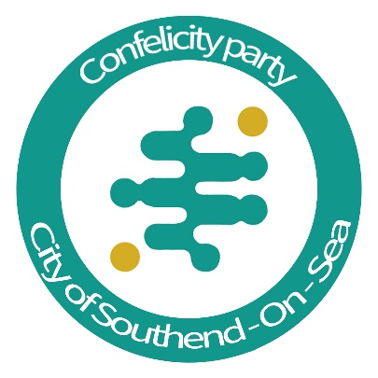

Confelicity Meeting Minutes
Date: 29th September 2025
Time: 7pm to 9pm
Location: Molo Lounge
Chair: James Miller

1. Digital ID Cards
Discussion Summary:
1.1 Diane expressed concerns regarding privacy and governmental overreach.
1.2 Hayley expressed disapproval.
1.3 Helen raised cybersecurity risks.
1.4 Lee C noted similar systems exist (e.g., passports, NI numbers) but questioned impact of removing alternatives.
1.5 Sue commented Digital ID may be part of a larger agenda.
1.6 Mike referenced Tony Blair’s Institute for Global Change and concerns over financial control.
1.7 Lee H, James, and others noted objections.
Action:
1.8 Item 15.1 – Lee H to submit FOI request regarding Digital ID implementation.
Decision:
1.9 Unanimous opposition from all attendees (100%).

2. Equal Representation in Schools (Youth Council Motion)
Motion by: Lee C
Proposal:
2.1 Every school, including those for troubled or special needs children, should be represented on the Youth Council.
Action:
2.2 Lee C to discuss further with Colin Campbell.
Decision:
2.3 Motion supported.

3. Translation Services in Schools and Councils
Discussion Summary:
3.1 Hayley: Funding is excessive but full cuts not advisable.
3.2 Lee C: Supports translation services for those with disabilities or learning difficulties.
3.3 Sue: Supports for legal contexts, questions overuse in secondary schools; supports for infants/emergencies.
3.4 Helen: Asked for clarity on council’s translator usage and broader context.
3.5 Concerns about use primarily for asylum cases; cap or devices suggested.
Suggestion:
3.6 Council to explore tech solutions to reduce translation costs.
Vote Results (Support for Tech to Reduce Costs):
3.7 Lee H: Support (100)
3.8 Diane: Support (100)
3.9 Lee C: Support (100)
3.10 Sue: Support (100)
3.11 Mike: Support (100)
3.12 Helen: Support (100)
3.13 Hayley: Opposed (1)
3.14 James: Support (100)

4. Car Park Access
Discussion Summary:
4.1 Sue inquired about regaining car park access.
4.2 Lee C proposed using Civic Centre.
4.3 Mixed responses – some abstained, some supported with varied strength.
Vote Results:
4.4 Diane: Abstained
4.5 Hayley: Abstained
4.6 Helen: Support (60)
4.7 Lee H: Support (1)
4.8 Mike: Support (49)
4.9 Sue: Support (1)
4.10 James: Support (20)

5. Community and Campaign Updates
5.1 Discussion about working with 200 Parish Councils.
5.2 Diane: Organising Thorpe Bay Broadway community day.
5.3 Lee C: Supporting residents' community efforts.
Campaign Ideas:
5.5 Partner with a charity for fundraising.
5.6 Identify/flag green belt developments early.
5.7 Organise parliamentary hustings.
5.8 Plan peaceful Kursaal awareness march (Lee C).
Other Notes:
5.9 Confirm meeting dates for the year.
5.10 Check quorum for future meetings.

Next Meeting: Tuesday, 4th November from 7pm to 9pm at Molo Lounge (downstairs)

